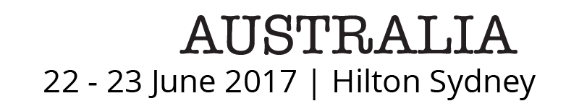

[Date]
Dear <First name of Employer>,

I would like to attend the Agile Australia 2017 Conference on Thursday 22 - Friday 23 June 2017 in Sydney, and and the <insert Workshop> on <Wednesday 21 June or Monday 27 June].

The Conference presents innovation strategies, tools, frameworks and better ways of working for individuals and organisations. It attracts over 1000 delegates annually and so offers invaluable opportunities for networking and professional development.

In 2017, the Conference will provide four streams on the theme of ‘Learning and Leading’, featuring internationally-renowned speakers on subjects including high-performing teams and organisations, management, systems and design thinking, complexity, UX and product management.

I would be happy to report back to my colleagues on the Conference speakers and other sessions, as well as any workshops I attend, and I could also provide briefs as required on the topics covered and share presentations from the speakers.

The cost to attend the Agile Australia 2017 Conference is: <insert relevant cost>:
[Single Conference Registration: $900 before 10 April 2017, $1100 thereafter
Full Day Workshop: $600 before 10 April 2017, $800 thereafter
Half Day Workshop: $350 before 10 April 2017, $450 thereafter]
Full details are available at www.agileaustralia.com.au/2017/

There is also an option to register a group of delegates from our organisation, which would entitle us to a 10% discount on registration fees. The Agile Australia workshops in particular are beneficial for groups, as over a half-day or full-day session our team can work on communication, collaboration and developing organisational culture.
Travel and accommodation costs for this Conference are estimated at <insert estimate>.

I believe my attendance at Agile Australia 2017: Learning and Leading will be enormously beneficial for professional development, networking, and enhancing a range of skills, from teamwork to communication. It is a unique opportunity to learn from leading minds in business innovation.
Yours sincerely,

<insert name>

